LEVEL 3, WEEK 1
STUDENT PACKET

ACTIVITY ONE:
FORMING QUESTIONS
Change the sentences into questions.

1.) She is happy.

_____________________________________________________________________________________________________________

2.) CORES is in Somerville.

_____________________________________________________________________________________________________________

3.) I am good.

_____________________________________________________________________________________________________________

4.) Dinner is delicious.

_____________________________________________________________________________________________________________

5.) The homework is easy.

_____________________________________________________________________________________________________________

6.) He is sad today.

_____________________________________________________________________________________________________________

7.) You are tired.

_____________________________________________________________________________________________________________

8.) The dogs are friendly.

_____________________________________________________________________________________________________________

ACTIVITY TWO: TOMMY AND MAX
Tommy, a young boy, visited the local zoo one sunny afternoon. As he strolled through the zoo, he came across a group of playful monkeys in a large enclosure.
One mischievous monkey, named Max, had a tendency for causing trouble. He had managed to snatch a shiny object from a visitor’s bag and was now dangling it high above the others. The rest of the monkeys watched in curiosity and excitement.

ACTIVITY THREE:
“TO DO”
Change the statement to a question.

Example:
She has three cats.
Does she have three cats?

1.) My mom has two jobs.

________________________________________________________________________________________________

2.) We have a big TV.

________________________________________________________________________________________________

3.) I have new shoes.

________________________________________________________________________________________________

4.) You have lots of homework.

________________________________________________________________________________________________

ACTIVITY FOUR:
“TO DO”
Look at the picture and answer the question.

Example:
Does John have a sister?
Yes, John has a sister.



Does he have a book? Do they have backpacks?

________________________________________________ __________________________________________________

________________________________________________ __________________________________________________

________________________________________________ __________________________________________________


Does she have a pencil?

_________________________________________________________

_________________________________________________________

_________________________________________________________

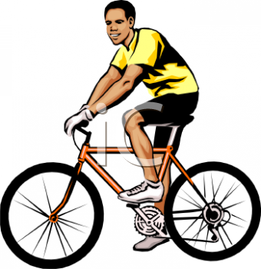

Do we have cell phones? Do you have a car?

_________________________________________________ _____________________________________________________

_________________________________________________ _____________________________________________________

_________________________________________________ ______________________________________________________

ACTIVITY FIVE:
PREPOSITIONS OF TIME
Fill in the blank with the appropriate word: Before, After, While, Until

1.) I eat breakfast at 6am and I go to work at 7am.

I eat breakfast____________________________work.

2.) My son watches TV at the same time that I cook dinner.

My son watches TV___________________________I cook.

3.) I will wait for you but I have to leave at 3 o’clock.

I will wait for you___________________________3 o’clock.

4.) I relax at 7pm and I get back from work at 6pm.

I relax_______________________work.

5.) I do not brush my teeth after I go to sleep.

I brush my teeth_______________________I go to sleep.

6.) Tomorrow she works from 9 o’clock to 5 o’clock.

She works _______________________5 o’clock

7.) I go to school in the morning and I eat lunch in the afternoon.

I go to school______________________I eat lunch.

8.) I listen to music at the same time that I ride the bus.

I listen to music_______________________I ride the bus.

9.) I take a shower at 10 pm and I got to work at 12am.

I take a shower_______________________I go to work.

ACTIVITY SIX:
ADVERBS OF FREQUENCY

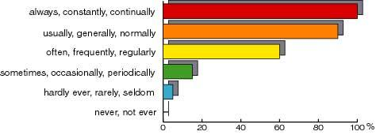

Write sentences using some of the words above.

1.)

2.)

3.)

4.)

5.)

6.)

ACTIVITY SEVEN:
A/AN
Circle the correct word for the object in each picture.

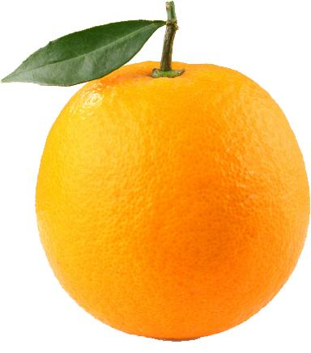

( A / AN ) apple ( A / AN ) orange

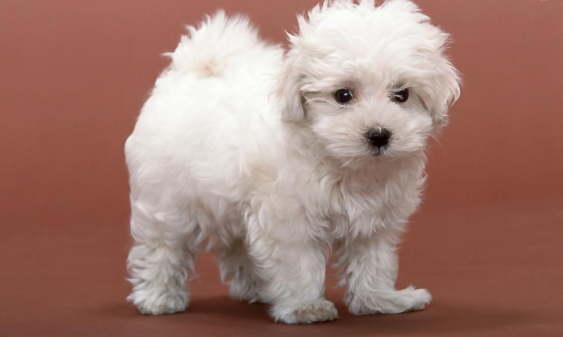
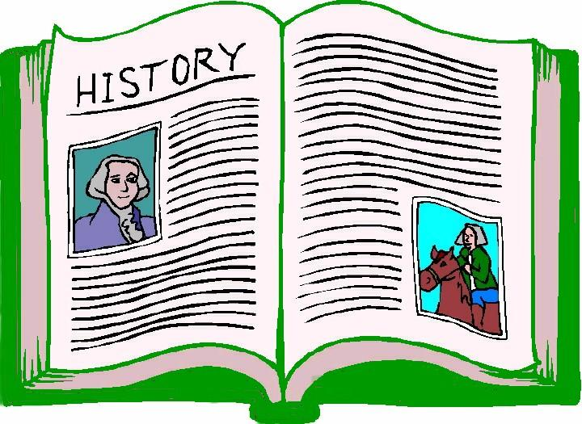

( A / AN ) dog ( A / AN ) history book



( A / AN ) student ( A / AN ) girl

ACTIVITY EIGHT:

“That Crazy Chimpanzee”
In a big city, there was a zoo. Kids loved to visit the zoo to see the animals. One day, as they watched the gorillas, something fun happened.
The biggest gorilla, like King Kong, reached out and grabbed a tree branch. He swung it around, and the kids thought it was funny. They laughed and clapped their hands.
The gorilla enjoyed playing with the branch, and the kids had a great time watching. When he was done, he let the branch go. The kids left the zoo with big smiles, having seen the gorilla’s playful moment..

ACTIVITY NINE:
“THERE IS/THERE ARE”
Change the statements to questions and change the questions to statements. Add “is”, “are”, or “am” depending on what fits in the sentence.

Examples:
___ there dogs in your house?
There are dogs in your house.

There ___ a spider in my room.
Is there a spider in my room?

1.) ___ there a computer in the library?

________________________________________________________________________________________________

2.) I ___ good at this game.

________________________________________________________________________________________________

3.) ___ there children in her neighborhood?

________________________________________________________________________________________________

4.) There ___ a lot of snow outside.

________________________________________________________________________________________________

ACTIVITY TEN:
TO BE/TO GO/TO HAVE (PAST TENSE)
Fill in the blank with the correct past tense form of the verb in parentheses.

1.) Yesterday I (to go) ____________________________________ to the zoo.

2.) When she was a child, she (to have) _________________________________a dog.

3.) You (to be) ___________________________________ not a nice person.

4.) We (to have) _________________________________ lots of fun last weekend.

5.) He (to go) ____________________________________ to the store.

6.) I (to be) _______________________________________ very happy last summer.

7.) They (to go) ____________________________________to the movies.

8.) We (to be) ______________________________________at school yesterday.

9.) You (to have)_____________________________________lots of friends.

10.) She (to be) _______________________________________my friend when we were children.

11.) I (to have) _______________________________________ lots of homework last week.

12.) They (to be) ______________________________________ neighbors.

